
UNIVERSITYOF ENGINEERING AND

TECHNOLOGY PESHAWAR
CS AND IT DEPARTMENT
Lab Task#01

Name: Ibtisam Ullah
Reg No: 24PWBCS1206
Section: A
Semester: 4th
Session: 2024-2028
Instructor Name: Sir Muhammad
Subject/Course: Web Technologies
Assignment Deadline: 25/02/2026

LAB TASK: 01
DELIVERABLE
Repository Link:
https://github.com/ibtisamukk/WT_SP_26
Screenshots:
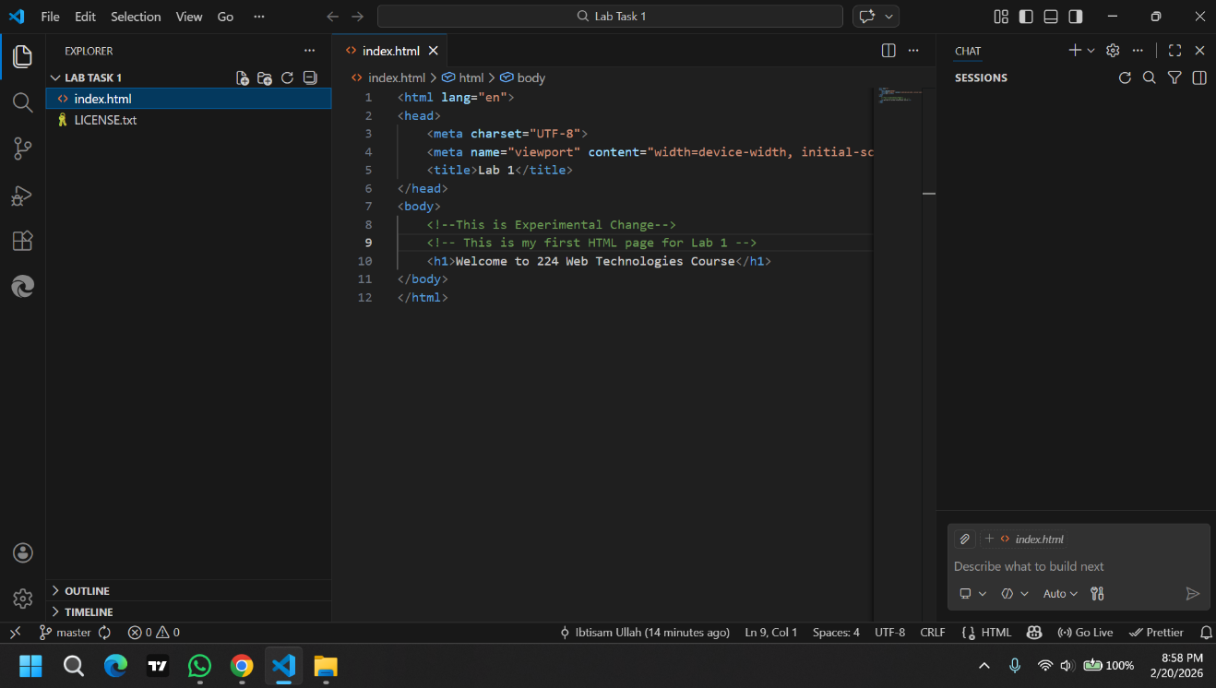



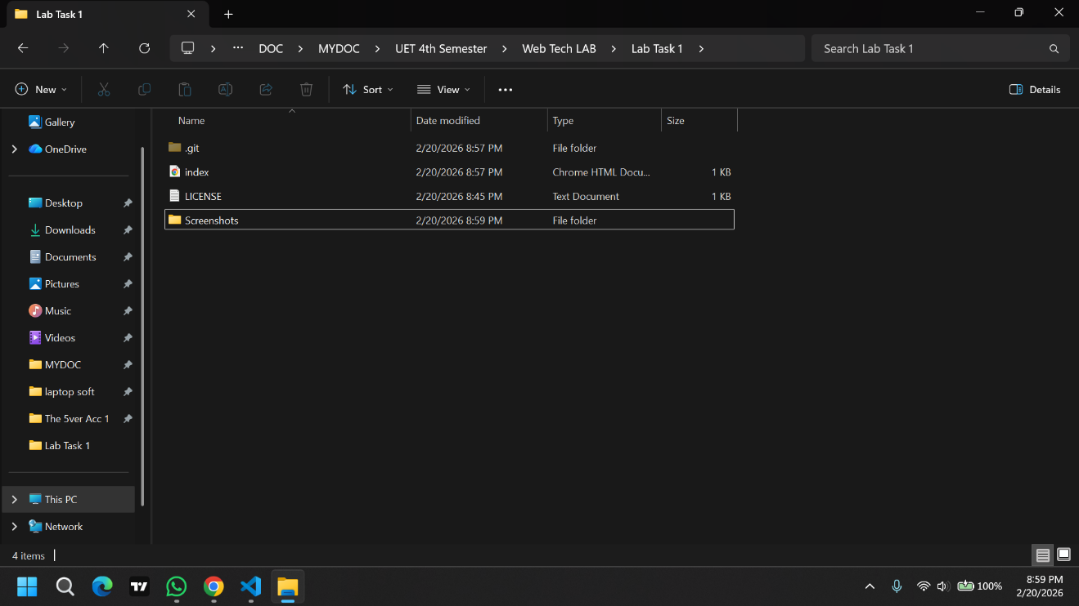

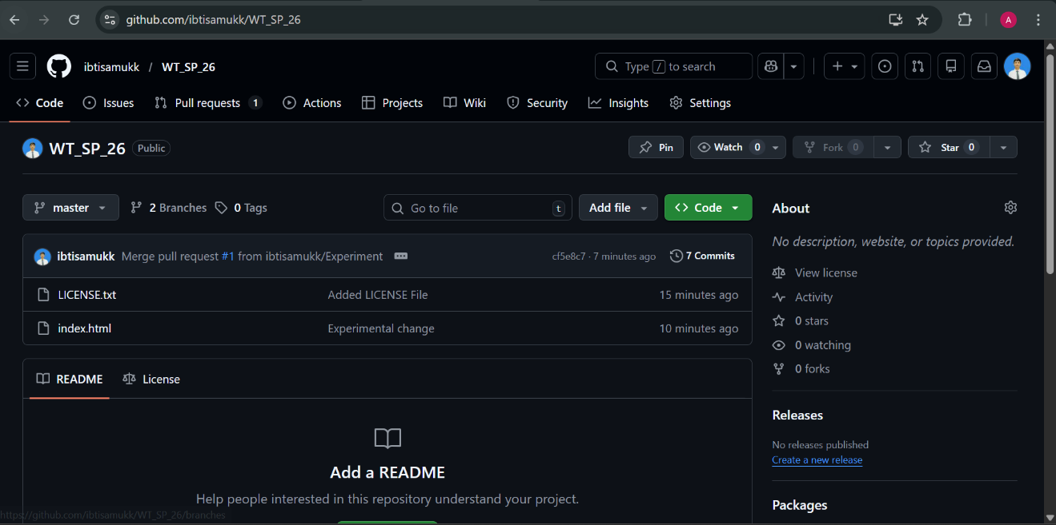

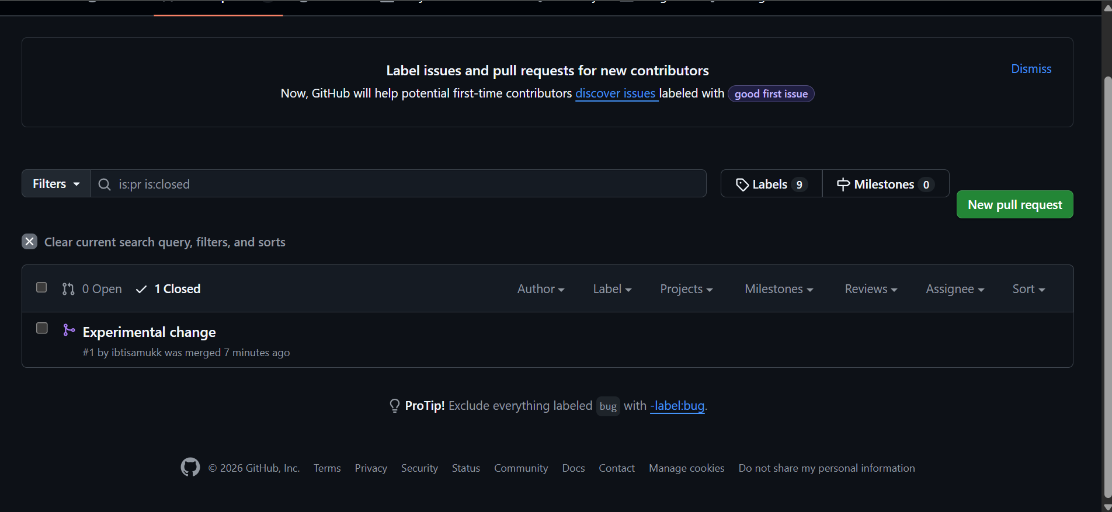
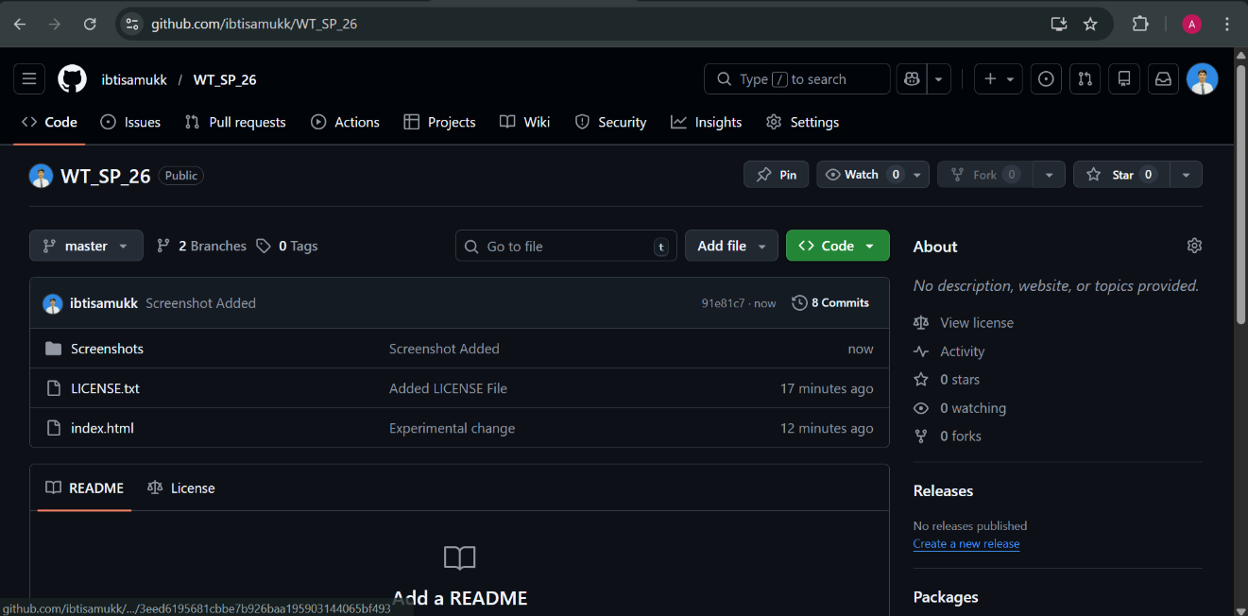
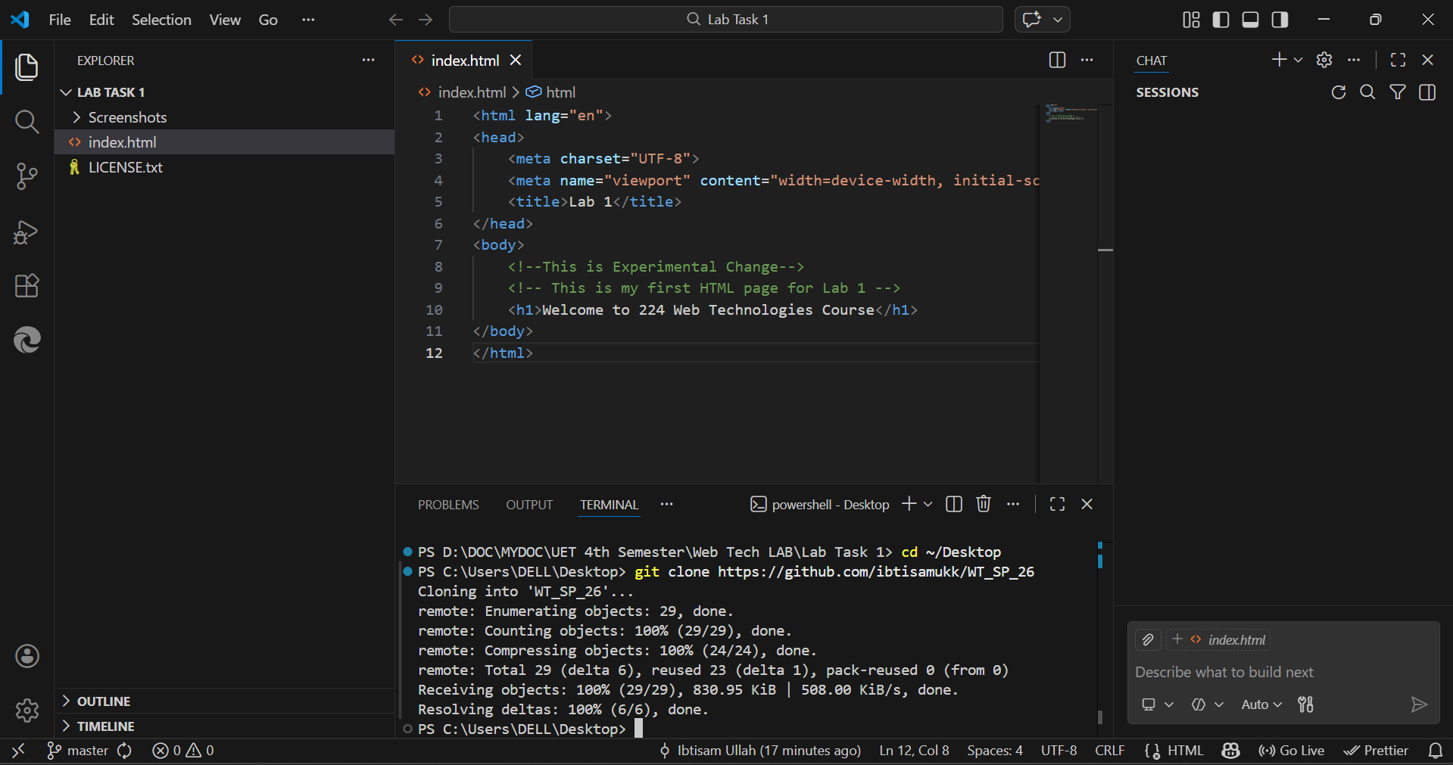
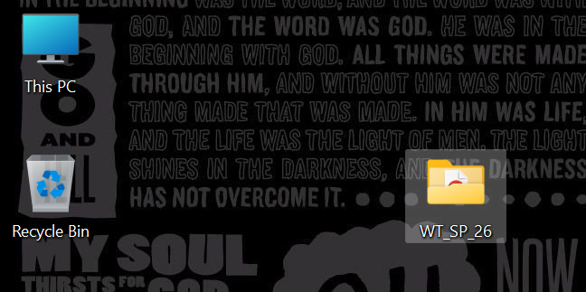
THANK YOU

